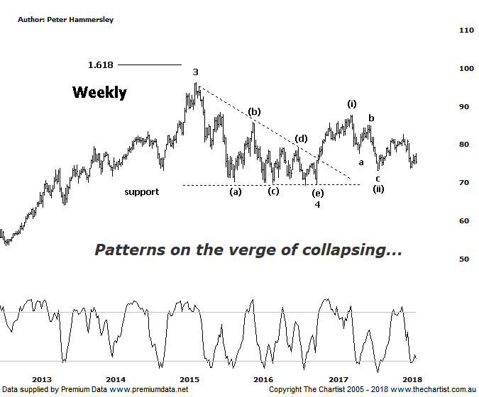

Bottom Line
16/3:
Daily Trend: Down
Weekly Trend: Down
Monthly Trend: Down
Support levels: $73.20 / $69.22
Resistance levels: $87.74 / $96.16 / $105.00
Video Analysis
Watch Video Analysis Here
Technical Discussion
Commonwealth Bank is Australia’s leading provider of integrated financial services including retail banking, premium banking, business banking, institutional banking, funds management, superannuation, insurance, investment and sharebroking products and services. The Group is one of the largest listed companies on the Australian Securities Exchange. It provides a full range of retail banking services including home loans, credit cards, personal loans, transaction accounts, and demand and term deposits through its Commonwealth Bank and Bankwest brands. The Group has leading domestic market shares in home loans, personal loans, retail deposits and discount stockbroking, and is one of Australia's largest credit card issuers. For the six months ending the 31st of December 2017 interest income increased 3% to A$17.18B. Net interest income after loan loss provision increased 7% to A$8.66B. Net income before extraordinary items increased 1% to A$4.9B. Broker/Analyst consensus is a “Hold”. The dividend yield is currently 5.7%.
Reasons to be cautiously optimistic:
→ Recent results surprised to the upside.
→ Selling the life business in Australasia should be positive for shareholders.
→ The recent announcement by APRA was less severe than originally anticipated.
→ Major banks should be able to offset the negative impact from the government levy by around 50%.
→ Regulatory fears eased.
→ Sold Visa shares which should improve capital ratios.
→ Improved discipline on mortgage pricing is required.
→ Healthy dividend over 5%.
For years we’ve been saying that CBA is our preferred bank of the big four and although our view hasn’t changed, a few cracks have started to show within the patterns. In fact, last time we noted that the smaller degree patterns were starting to fail due to price heading down through the typical retracement zone. This evening I’m going to flip back to the weekly chart which also shows that the patterns have started to deviate from the ideal path. Our labelling remains intact with the triangle completing wave-4 which was followed by an impulsive movement higher. The problem is that the retracement from the high of wave-(i) is not only deep but there are now question marks as to whether wave-(ii) is in place which again is due to an untypically deep retracement. At the end of the day’s it’s looking much more unlikely that we are going to see a strong impulsive movement higher within wave-(iii) which opens the door for something a little less bullish to unfold. Price would need to head straight up through the prior pivot high around $82.66 to get these patterns back on track although the lack of demand currently suggests this is going to be a tough hurdle to crack. It’s more likely that price is going to continue to consolidate and remain range bound which has pretty much been the case since 2015. However, CBA is still the only bank that could feasibly embark on a 5-wave move from the 2009 lows although it’s looking much more unlikely than it was a few months ago. As we’ve mentioned in recent reviews of the banks, with a lack of growth and a possibly higher interest rate environment, it’s difficult to envisage what the trigger for a multi-month or even a multi-year trend is going to be. That’s not to say something can’t come out of left field but for now the fundamental and technical picture appear to be aligning - and not for the better.
Trading Strategy
Although longer-term there is still every reason to keep an eye on the stock, the better patterns can be found elsewhere within the sector. As such, we’ll continue to stand aside until some clarity returns which it almost certainly will. If you still want to be involved in the big four banks, then perhaps look at ANZ which we reviewed on Wednesday. This shows a large consolidation pattern which always keeps the door open for an upside breakout. In fact, should the patterns on that chart continue to unfold in textbook fashion a formal recommendation shouldn’t be too far away.

Disclosure: Nick Radge holds

