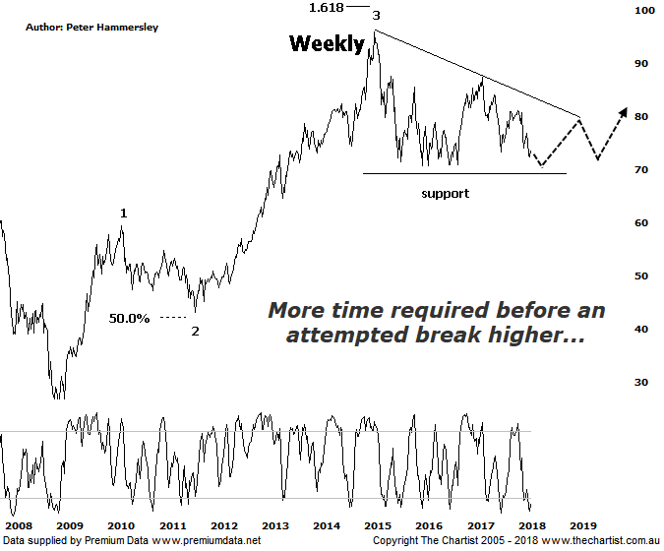

Bottom Line
12/4:
Daily Trend: Up
Weekly Trend: Down
Monthly Trend: Down
Support levels: $69.22 / $60.00 / $51.50
Resistance levels: $87.74 / $96.16 / $105.00
Video Analysis
Watch Video Analysis Here
Technical Discussion
Commonwealth Bank is Australia’s leading provider of integrated financial services including retail banking, premium banking, business banking, institutional banking, funds management, superannuation, insurance, investment and sharebroking products and services. The Group is one of the largest listed companies on the Australian Securities Exchange. It provides a full range of retail banking services including home loans, credit cards, personal loans, transaction accounts, and demand and term deposits through its Commonwealth Bank and Bankwest brands. The Group has leading domestic market shares in home loans, personal loans, retail deposits and discount stockbroking, and is one of Australia's largest credit card issuers. For the six months ending the 31st of December 2017 interest income increased 3% to A$17.18B. Net interest income after loan loss provision increased 7% to A$8.66B. Net income before extraordinary items increased 1% to A$4.9B. Broker/Analyst consensus is a “Hold”. The dividend yield is currently 5.8%.
Reasons to be cautiously optimistic:
→ Recent results surprised to the upside.
→ Selling the life business in Australasia should be positive for shareholders.
→ The recent announcement by APRA was less severe than originally anticipated.
→ Major banks should be able to offset the negative impact from the government levy by around 50%.
→ Regulatory fears eased.
→ Sold Visa shares which should improve capital ratios.
→ Improved discipline on mortgage pricing is required.
→ Healthy dividend over 5%.
We mentioned last time that the patterns were on the verge of collapsing which was due to the uncharacteristically deep retracement off the April 2017 high. Further weakness over the past few weeks hasn’t quite invalidated our wave count although the writing appears to be on the wall, so we have amended our labelling. Not that it’s all doom and gloom although it’s would be fair to say that more time is required before an attempted rally of substance kicks into gear. I have put forward a possible descending triangle on this weekly chart although it must be said it’s not a textbook example. As such, we must retain a cautious stance as the patterns currently lack clarity both on this, and the daily chart. It’s worth reiterating that CBA is still the only bank that can form a 5-wave movement higher off the 2009 lows. A push beneath the lower boundary of the triangle would likely be the final nail in the coffin though and suggest a corrective pattern higher has been unfolding over the years which is the case with the other big 3 banks. This wouldn’t be the end of the world as we still believe the Banking sector will embark on another substantial leg north, albeit it could be much further down the track and from lower levels. As we’ve been saying for many months now, we believe the Materials sector has much more upside potential over the near-term which thus far is proving to be correct. If an Elliott triangle proves to be the way forward here, then the lower boundary around $70.00 should hold a few buyers and trigger a bounce back up toward $80.00. This should be followed by one final probe down to complete the 5-internal swings and larger degree wave-4. This would be the perfect pattern from an Elliott stance though with global equity markets increasing in volatility nothing is set in stone.
Trading Strategy
With the smaller degree patterns continuing to take a turn for the worse there is still every reason to stand aside. Should the triangle scenario play out it’s likely going to be several months before an opportunity to the long side presents itself. On the flipside, a break down through the lower boundary of the triangle (which essentially is strong horizontal support) we’ll be looking for shorting opportunities. Either way, there’s no reason to be concentrating on the banks from a trading point of view. The only positive at this stage is the dividend yield which of course becomes more attractive as price heads lower. This will likely limit downside.

