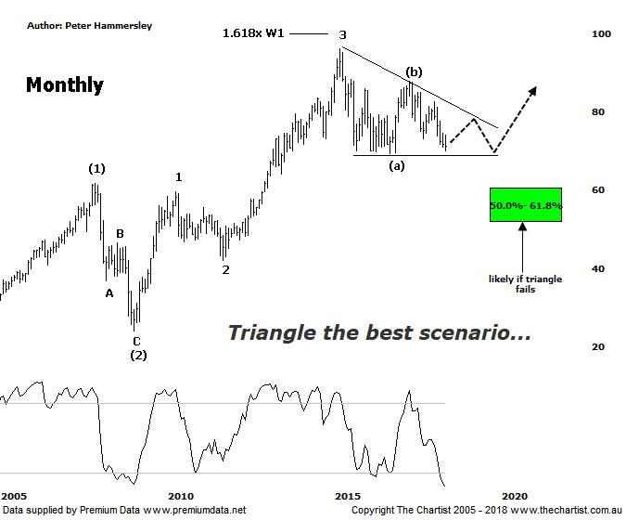

Bottom Line
17/5:
Daily Trend: Down
Weekly Trend: Down
Monthly Trend: Down
Support levels: $69.22 / $60.00 / $51.50
Resistance levels: $87.74 / $96.16 / $105.00
Video Analysis
Watch Video Analysis Here
Technical Discussion
Commonwealth Bank is Australia’s leading provider of integrated financial services including retail banking, premium banking, business banking, institutional banking, funds management, superannuation, insurance, investment and sharebroking products and services. The Group is one of the largest listed companies on the Australian Securities Exchange. It provides a full range of retail banking services including home loans, credit cards, personal loans, transaction accounts, and demand and term deposits through its Commonwealth Bank and Bankwest brands. The Group has leading domestic market shares in home loans, personal loans, retail deposits and discount stockbroking, and is one of Australia's largest credit card issuers. For the six months ending the 31st of December 2017 interest income increased 3% to A$17.18B. Net interest income after loan loss provision increased 7% to A$8.66B. Net income before extraordinary items increased 1% to A$4.9B. Broker/Analyst consensus is a “Hold”. The dividend yield is currently 6.1%.
Reasons to be cautiously optimistic:
→ Recent results surprised to the upside.
→ Selling the life business in Australasia should be positive for shareholders.
→ The recent announcement by APRA was less severe than originally anticipated.
→ Major banks should be able to offset the negative impact from the government levy by around 50%.
→ Regulatory fears eased.
→ Sold Visa shares which should improve capital ratios.
→ Improved discipline on mortgage pricing is required.
→ Healthy dividend over 6%.
Commonwealth Bank has been our favourite of the big four for many years now and although this is still the case in the competition has caught up. That said, it’s still the only one of the big four that can make a 5-wave movement higher off the 2009 lows. That said, recent weakness is putting this more bullish interpretation under serious pressure. Our stance 12 months ago was that a descending triangle had already completed wave-4 although the lack of follow-through to the upside suggests otherwise. However, the triangle remains in position, albeit it has morphed into a larger pattern - assuming it continues to form. The recent move lower should complete wave-(c) shortly if it isn’t locked-in already. In our review of the Banking sector (XXJ) which we also cover this evening, a low appears to be locked-in which aligns nicely with this chart. Should this be correct then the risk is to be upside over the next three or four months as a minimum although price still needs to prove itself. As always, we like to see these patterns contain 5-internal swings which is the reason we can’t get overly enthusiastic yet, as we are only currently only completing the 3rd swing. In other words, the broader sideways move is expected to continue with any strength being relatively short-lived although of course we are looking at the monthly chart here. The worst-case scenario is to head down through the lower boundary of the pattern and the recent pivot low at $69.22. Should this transpire in a move that sticks, then we start looking at a more conventional zigzag correction which should take price down into the typical retracement zone as annotated. Interestingly, the wave equality projection aligns with the 50% retracement level around $60.00 providing some confluence. In other words, buyers are likely to step up around the upper boundary of the target area should the recent consolidation pattern break to the downside. This would result in us amending our wave count although we’ll revisit that scenario later down the track if the patterns take a turn for the worse. The bottom line is, buyers need to step immediately if a deeper retracement is to be avoided.
Trading Strategy
It seems like an eternity since we’ve been involved in any of the big four banks which is solely down to the patterns which have continued to advocate caution. It’s been a good sector to avoid over recent years and there’s no reason to rush back into it quite yet. Yes, there is upside potential over the coming months if the triangle continues to prove although the patterns still need to prove themselves. We’ll happily continue to remain sidelined. Companies in other sectors continue to offer opportunities which is why we’ll keep our focus elsewhere until the patterns here entice us back.

