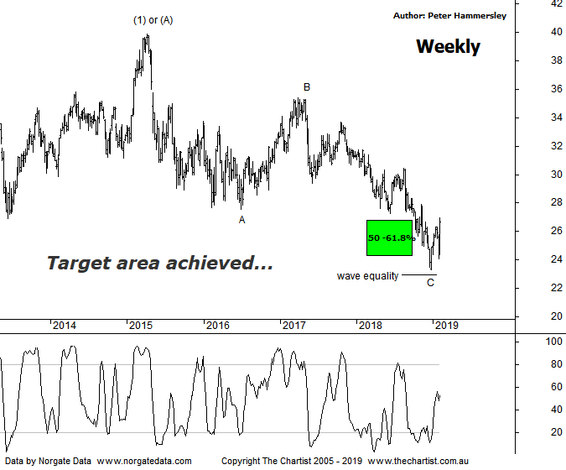

Bottom Line
5/2:
Daily Trend: Up
Weekly Trend: Up
Monthly Trend: Down
Support Levels: $23.30 - $22.97
Resistance Levels: $27.24 - $29.03
Video Analysis
Watch Video Analysis Here
Technical Discussion
Westpac is Australia’s oldest banking group which operates throughout Australia and New Zealand. It is divided into three core businesses: Australian Financial Services, Institutional and New Zealand. Other brands it operates are St George, Bank of Melbourne, BankSA, RAMS and BT Financial Group. The recent period of NZ bank earnings out performance over Australia is now coming to an end. NZ is coming off a cyclical peak of bad debt reduction analysts suggest the challenges ahead appear to be manageable. For the six months ending the 31st of March 2018 interest income increased 5% to A$16.09B. Net interest income after loan loss provision increased 11% to A$7.89B. Net income applicable to shareholders increased 7% to A$4.2B. Net interest income after loan loss provision highlights the Consumer Bank section increase of 4% to A$3.81B and the Group Businesses section increase of 31% to A$424M. The dividend yield is 7.6%. Broker consensus is currently “Hold”.
Reasons to be more optimistic:
→ Positive reaction to the Royal commission findings.
→ First major bank to announce mortgage re-pricing.
→ Major banks are still expected to re-price home loans.
→ Asset quality and capital levels remain strong.
→ Continues to do well in transaction banking.
→ Good growth prospects compared to its peers.
→ Has defensive qualities and is not exposed significantly to volatility in mining or NZ dairy.
→ A low risk profile coupled with cost discipline.
→ Defensively positioned loan book.
→ A line of support continues to attract demand.
The banks were in great demand today thanks to the final findings by the Royal commission which weren’t as bad as many feared. Not that we can read too much into one day’s price action although in this instance today’s strength aligns with the patterns we’ve been following which now suggest a major low is locked in. We’ll stick with the weekly chart this evening which shows that the wave equality projection we’ve been watching came within a whisker of being tagged a few weeks ago and in this instance close enough is good enough. What we are left with now is the strong rally off the 2009 lows which culminated in locking in wave-(1) or-(A). This has been followed by an almost textbook zigzag which terminated just beneath the 61.8% retracement level and slightly above the wave equality projection as just mentioned. In other words, from an Elliott stance now is the perfect time for the next leg higher to kick into gear. If we are correct with the wave count there’s no reason why a multi-year trend can’t unfold, which should be similar in length to the rally off the 2009 lows. Should this transpire then something much more bullish is likely going to unfold in the XJO which still needs to prove itself. One thing is for sure, if the big four banks rally hard from here then the XJO is going to embark on a similar trajectory. It’s worth remembering that the banks account for almost 30% of the index. Also, the Materials sector is looking stronger which adds even more weight to a more bullish outcome. All that being said, the prerequisite is that impulsive price action must continue within the Banking sector, as any choppy patterns over the coming weeks will move us back to a neutral stance. It will be interesting to see if today’s strength continues throughout the rest of the week as it certainly needs to.
Trading Strategy
Today’s massive gap higher means on the daily chart a low risk entry isn’t presenting itself which under normal circumstances would leave us waiting on the sidelines. However, when looking at this weekly chart it’s a different story. If you want exposure to the banks, then Westpac is showing the better patterns from an Elliott perspective meaning it should be on the radar. You could buy around current levels and place the protective stop just beneath the prior pivot low at $23.29 which is still a nice setup, especially on this longer timeframe. A trailing stop should be used to manage the position. This is suited to both the short and longer term trader or investor and I will be making a formal recommendation in the position status page this evening.

