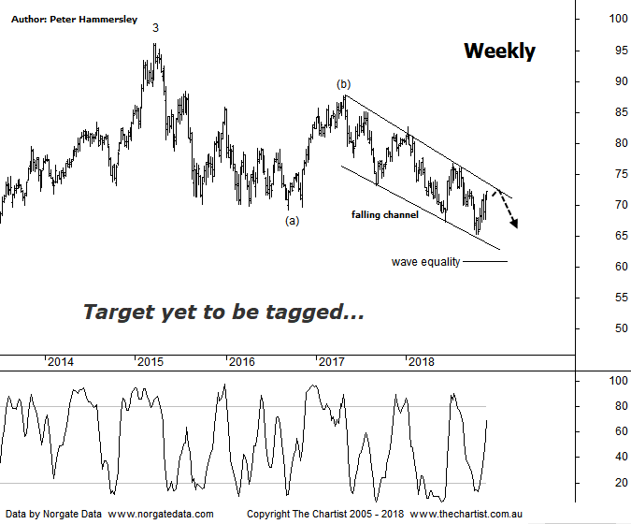

Bottom Line
27/11:
Daily Trend: Up
Weekly Trend: Up
Monthly Trend: Neutral
Support levels: $60.74 - $60.00 / $51.50
Resistance levels: $87.74 / $96.16 / $105.00
Video Analysis
Watch Video Analysis Here
Technical Discussion
Commonwealth Bank is Australia’s leading provider of integrated financial services including retail banking, premium banking, business banking, institutional banking, funds management, superannuation, insurance, investment and sharebroking products and services. The Group is one of the largest listed companies on the Australian Securities Exchange. It provides a full range of retail banking services including home loans, credit cards, personal loans, transaction accounts, and demand and term deposits through its Commonwealth Bank and Bankwest brands. The Group has leading domestic market shares in home loans, personal loans, retail deposits and discount stockbroking, and is one of Australia's largest credit card issuers. For the year ending the 30th of June 2018 income increased 4% to A$34.54B. Net interest income after loan loss provision increased 5% to A$17.26B. Net income before extraordinary items decreased 4% to A$9.38B. Net interest income after loan loss provision highlights the retail banking services section increase of 7% to A$9.08B and the Bank west section increase of 10% to A$1.51B. Broker/Analyst consensus is “Hold”. The dividend yield is currently 6.0%.
Reasons to be cautiously optimistic:
→ Recent results surprised to the upside.
→ Selling the life business in Australasia should be positive for shareholders.
→ The recent announcement by APRA was less severe than originally anticipated.
→ Major banks should be able to offset the negative impact from the government levy by around 50%.
→ Regulatory fears eased.
→ Sold Visa shares which should improve capital ratios.
→ Improved discipline on mortgage pricing is required.
→ Healthy dividend of over 6%.
Most brokers have been sitting on the fence over the past few months with almost all having “neutral” ratings on the big four banks. However, both Morgans and Credit Suisse recently became more bullish on CBA and have put out “buy” recommendations. The latter suggests the recent update was robust and cited falling operating expenses and a strong capital position as being reasons to be more optimistic. The on-going problem for the banks is the regulatory and compliance headwinds although slowly but surely these appear to be being dealt with. Let’s not forget, the market doesn’t like uncertainty, which has undoubtedly been the situation within the sector. We tend to agree in that there is upside potential over the medium to longer term although we wouldn’t be buying right here and now in anticipation of a multi-year trend unfolding. Last time we noted that price had broken down through the lower boundary of a descending triangle which invalidated the pattern. Not ideal, although it didn’t portend anything sinister - and still doesn’t. However, nothing changes in that we now expect a zigzag to unfold which should take price down to the wave equality projection as annotated at $60.74. That’s still a reasonable percentage loss from current levels and it could take several months to get down into that target area. That said, if buyers step up to the plate at those lower levels, we’d be looking for a strong reversal higher. The other pattern of interest is the falling channel from the high of wave-(b), with the upper trend line needing to be watched for an upside breakout. On the daily chart (not shown) Type-A bearish divergence is in position with price making a higher high whilst our oscillator has failed to confirm that strength by making a lower high. It’s yet to trigger but should this be the way forward then a short retracement or consolidation will likely follow.
Trading Strategy
Both from a pattern and a trading perspective we’d still like to see further weakness as this will provide symmetry and a low risk entry. If you are more aggressive you could buy following a break through the upper boundary of the falling channel though I won’t be making a formal recommendation. Wave-(c) should head to lower levels to complete the whole corrective pattern which is where we’ll be looking for a buying opportunity.

