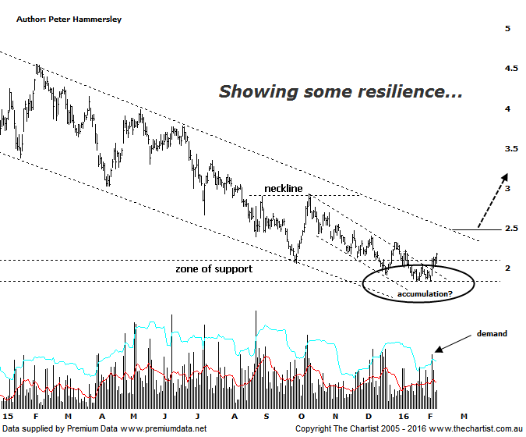

Bottom Line
9/2:
Daily Trend: Up
WeeklyTrend: Down
Monthly Trend: : Down
Support Levels: $1.84
Resistance Levels: $2.93 / $3.78
Video Analysis
Watch Video Analysis Here
Technical Discussion
Western Areas (WSA) is an Australian based producer of nickel. It is involved in mining, processing and the sale of nickel sulphide concentrate as well as the continued assessment, feasibility and development of nickel mines and the exploration for nickel sulphides. It operates the Forrestania project, which consists of Flying Fox and Spotted Quoll nickel mines and the Cosmic Boy Concentrator which treats the high grade ore and produces nickel concentrate for sale. The Company’s subsidiaries include Western Platinum NL, Australian Nickel Investments Pty Ltd, Bioheap Ltd and Western Areas Nickel Pty Ltd. For the fiscal year ending the 30th of June 2015 revenues decreased 2% to A$312.7M. Net income increased 33% to A$35.8M. Revenues reflect a decrease in demand for the Company's products and services due to poor market conditions. Broker consensus is currently “Buy”. The dividend yield is 3.3%.
Reasons to be cautiously optimistic:
→ Cash flow should remain positive due to the company pushing out $33m of FY16 capex out to FY17.
→ Highly leveraged to an increase in nickel prices.
→ A lower Australian dollar offsets price downgrades.
→ Price has hit a zone of support and reversed strongly.
The upper boundary of a small falling channel had been penetrated just prior to our last look at WSA which was a small step in the right direction. However, once again we are left with a failed breakout which have been the curse of our market over the past few years. That said, the upper boundary of that channel has again been penetrated with a few buyers still stepping up around the lower boundary of the zone of support. Bigger picture of course we need to see the upper trend line of the larger falling channel overcome before getting overly confident medium to longer term but the recent show of resilience is at least a start; as is the buying demand around the zone of support. The recent show of resilience has partly been down to bullish divergence on the daily chart shown here although this is no longer providing a helping hand with our oscillator now sitting in the overbought position. This doesn’t automatically portend a leg lower but it does mean that the tailwind that’s been apparent over the past few days has now petered out. Looking at the weekly chart (not shown) highlights the severity of the movement down off the September 2014 highs with price declining over 65% down to the recent pivot low. From the all-time highs that number increases substantially although there is no point going into detail. The bottom line is that the downtrend is still firmly entrenched despite the fact we are technically in a position to see a rally of some magnitude.
Trading Strategy
Although I wouldn’t go the full hog you could initiate partial positions right here if you like the company although the initial stop would need to be placed just beneath the prior pivot low at $1.83 as a push beneath that level would ring the alarm bells. You can always top up once a high swing low pattern or similar bullish pattern forms. Longer term investors should stand aside until the upper boundary of the larger falling channel is breached which means some patience is going to be required before getting involved. We can only view WSA as a recovery play, albeit with plenty of upside potential.

