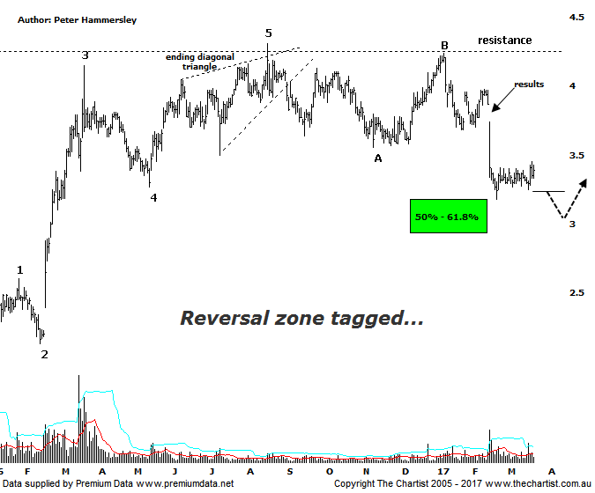

Bottom Line
22/3:
Daily Trend: Up
WeeklyTrend: Down
Monthly Trend: Down
Support Levels: $3.18 - $2.92 / $2.13 - $2.06
Resistance Levels: $4.24 - $4.31
Video Analysis
Watch Video Analysis Here
Technical Discussion
Primary Health Care (PRY) is a medical center operator. The Company also operates as a provider of diagnostic imaging services, a provider of pathology services, and a provider of health technology. It provides a range of services and facilities to healthcare practitioners, and its medical center operations include the provision of day surgery and in vitro fertilization services by healthcare practitioners. Its sections include Medical Centres, Pathology, Imaging and Health Technology. The Medical Centres division provides services and facilities to general practitioners, specialists and other healthcare providers, including Transport Health. For the six months ending the 31st of December 2016, revenues decreased 1% to A$808.7M. Net income before extraordinary items decreased 66% to A$21.1M. Revenues reflect a decrease in demand for the Company's products and services due to unfavorable market conditions. Broker consensus is currently “sell”. The dividend yield is 3.6%.
Reasons to be more optimistic:
→ Regulatory intervention is still a risk, but is easing.
→ Management are confident of the outlook despite weak results.
→ Confidence regarding increasing cash generation has improved.
→ Doctor Capex is under control whilst pathology remains the key driver.
→ Price has retraced into a potential reversal zone.
Most brokers believe that recent results were exceptionally weak. On the face of it they were correct with price gapping down on the 15th of February resulting in a substantial percentage loss. However, despite slightly lower levels being tagged a few buyers have started to take an interest. Not that a strong reversal higher has kicked into gear although some headway has been made. Indeed, on Monday price broke higher out of a small consolidation pattern. There was no follow-through yesterday although today was much improved, especially considering the broader market weakness following the sell-off on Wall Street overnight. It’s still early days although the larger degree patterns look textbook. A 5-wave movement completed via an ending diagonal triangle, also known as rising wedges which are strong reversal patterns. The subsequent retracement has also unfolded in 3-waves with the recent pivot low tagging the 50% retracement level at $3.18 to the cent. My only slight concern is that the leg lower from the high of wave-B doesn’t contain the required 5-internal swings which is keeping the door open for one final probe down which could take out the recent pivot low by a small margin. Should this transpire then a buying opportunity is going to present itself deeper into the target area in a few weeks time. A push above $3.60 however would suggest a low is already locked in making it a level to keep a close eye on. Whether one final probe South is required or not, the larger degree patterns portend another significant leg higher.
Trading Strategy
If you are more aggressive, the strategy is to buy following a break above yesterday’s high at $3.45 with the initial stop placed just beneath the recent pivot low at $3.17. The initial target is the line of resistance as annotated up around $4.20 though bigger picture higher levels should be attainable. However, with the risk of getting one final probe down still real, the formal recommendation is to stand aside although we’ll be keeping a close eye on the smaller degree patterns over the coming days for an entry. Don’t be surprised to see this in the position status page shortly.

