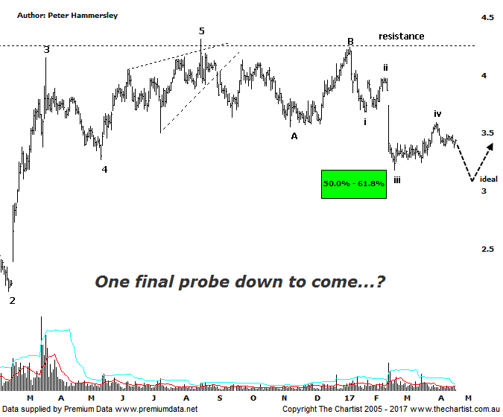

Bottom Line
21/4:
Daily Trend: Neutral
WeeklyTrend: Down
Monthly Trend: Down
Support Levels: $3.18 - $2.92 / $2.13 - $2.06
Resistance Levels: $4.24 - $4.31
Video Analysis
Watch Video Analysis Here
Technical Discussion
Primary Health Care (PRY) is a medical center operator. The Company also operates as a provider of diagnostic imaging services, a provider of pathology services, and a provider of health technology. It provides a range of services and facilities to healthcare practitioners, and its medical center operations include the provision of day surgery and in vitro fertilization services by healthcare practitioners. Its sections include Medical Centres, Pathology, Imaging and Health Technology. The Medical Centres division provides services and facilities to general practitioners, specialists and other healthcare providers, including Transport Health. For the six months ending the 31st of December 2016, revenues decreased 1% to A$808.7M. Net income before extraordinary items decreased 66% to A$21.1M. Revenues reflect a decrease in demand for the Company's products and services due to unfavorable market conditions. Broker consensus is currently “sell”. The dividend yield is 3.5%.
Reasons to be more optimistic:
→ Regulatory intervention is still a risk, but is easing.
→ Management are confident of the outlook despite weak results.
→ Confidence regarding increasing cash generation has improved.
→ Doctor Capex is under control whilst pathology remains the key driver.
→ Price has retraced into a potential reversal zone.
The big question during our last review was whether the corrective pattern had run its course, especially as the 50% retracement level had been tagged and rejected. Our stance was to be cautious. Although slightly higher levels have been tagged, price action has been choppy and messy in nature which isn’t indicative of the strong prior uptrend reigniting. As such, our stance means the same in that there is still a chance of getting one final probe down which should terminate deeper into the target zone either side of $3.00. If we zoom into the smaller degree patterns, specifically from the 9th of January high this year it’s evident that a 3-wave movement completes the recent pivot low. Wave-C should contain 5-internal swings which is another reason to be slightly sceptical regarding the recent rally. From a pattern perspective the current chop is more indicative of a minor degree wave-iv which is how we’ve labelled the chart. As long as price pushes down toward the low of wave-iii, and ideally beneath, there’ll be much more symmetry which in turn provides us with improved clarity. Whether we get the one final probe down remains to be seen although bigger picture there is plenty of upside potential ahead, even regarding a larger corrective pattern higher which is still our highest expectation. One thing is definite, an immediate push up through the lows of wave-i means the corrective pattern has run its course which provides us with a make or break level at $3.68.
Trading Strategy
We are keen to get involved here although it’s still a little early to be jumping on despite the upside potential over the medium to longer term. However, we’ll be placing PRY toward the top of our short-term watchlist as one final probe down toward $3.00 followed by clear demand would gain our interest. On the flipside, a push up through the aforementioned line in the sand at $3.68 would also be reason to look for an opportunity to jump on.

