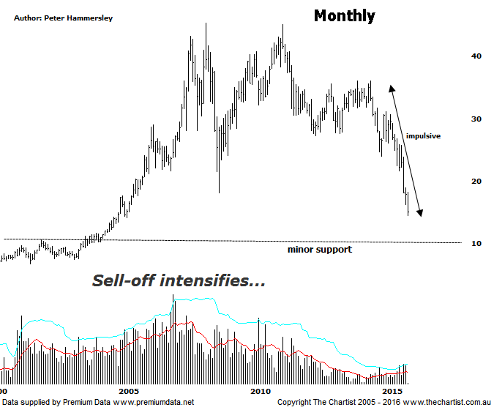

Bottom Line
15/1:
Daily Trend: Down
Weekly Trend: Down
Monthly Trend: Down
Support levels: $10.00 - $9.00
Resistance levels: $31.06 / $36.05
Video Analysis
Watch Video Analysis Here
Technical Discussion
BHP Billiton is a diversified natural resources company and operates through customer sector groups (CSGs). The Company operates in nine sections; Petroleum, Aluminium, Base Metals, Diamonds and Specialty Products, Stainless Steel Materials, Iron Ore, Manganese, Metallurgical Coal and Energy Coal. In May 2014, Cassini Resources acquired BHP Billiton Limited's West Musgrave Project. For the year ending the 30th of June 2015 revenues decreased 21% to $44.64B. Net income before extraordinary items declined 75% to $3.42B. Revenues reveal Group Production reduction of 21% to $43.46B. Broker/Analyst consensus is currently “Hold”. The dividend yield is 12.0%.
Reasons to be very cautious:
→ Increased chance of legal action over the Samarco mine disaster.
→ Dividend yield under threat.
→ Potential reversal zone now penetrated.
→ Commodity prices continue to head lower.
Strangely enough several brokers have just issued “buy” recommendations on BHP although from a fundamental point of view it’s difficult to understand why. For one thing, most analysts have lowered forecasts for iron Ore which obviously isn’t going to help matters and secondly the decline in the price of crude oil is also going to affect earnings negatively. No doubt these issues will already be factored into prices to some extent but until signs of a commodity turnaround start to show it’s difficult to envisage this company gaining a significant head of steam. As with any stock that is suffering technical damage, there is scope for a swift counter trend movement higher though at this stage that’s all we can expect - a short-term rally and nothing more. There is little to be gained by looking at the daily chart which just shows an almost straight line movement down. As such, this evening we are actually going to take a look at the monthly time frame which puts the recent retracement into perspective. It clearly shows the severity of the movement down that commenced in April 2011 which has culminated in a decline of around 68% thus far. These larger degree patterns portend even lower prices although the problem we have now is that there isn’t a great deal of support beneath current levels. Indeed, we have to go all the way back to 2002 where price was sitting around $10.00 to find any sort of support at all although it’s by no means a high probability reversal zone. Realistically all we can do here is look for signs that the smart money is taking an interest which often shows through the volume characteristics. One thing’s for sure, there’s no sign of significant demand returning at this stage which again means extreme caution is required.
Trading Strategy
“…A small micro triangle or similar will provide a set-up if you are actively looking for shorting opportunities...”. There is still no reason to deviate from this stance with the risk still being to the downside, albeit there is scope for a short bounce due to the oversold state of the stock. However, any rally accompanied by low volume which becomes choppy and messy in nature will be viewed as a shorting opportunity. If you’re looking for a longer term buying opportunity within the sector, more time is going to be required before taking a position. BHP will undoubtedly make a strong come-back but likely from lower levels.

