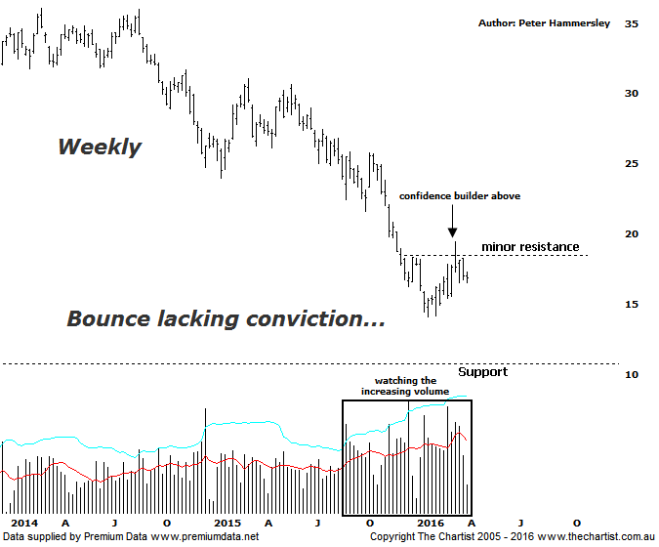

Bottom Line
31/3:
Daily Trend: Down
Weekly Trend: Up
Monthly Trend: Down
Support levels: $14.06 / $10.00 - $9.00
Resistance levels: $19.44 / $27.00 - $31.06 / $36.05
Video Analysis
Watch Video Analysis Here
Technical Discussion
BHP Billiton is a diversified natural resources company and operates through customer sector groups (CSGs). The Company operates in nine sections; Petroleum, Aluminium, Base Metals, Diamonds and Specialty Products, Stainless Steel Materials, Iron Ore, Manganese, Metallurgical Coal and Energy Coal. In May 2014, Cassini Resources acquired BHP Billiton Limited's West Musgrave Project. For the six months ending the 31st of December 2015 revenues decreased 37% to $15.71B. Net loss before extraordinary items was $5.67B against income of $3.86B. Revenues echo the Petroleum section decrease of 45% to $3.8B and the Iron Ore division decrease of 36% to $5.35B. Broker/Analyst consensus is currently “Hold”.
Reasons to be very cautious:
→ Spot gas prices are at their lowest level since 2001.
→ The dividend has been cut substantially.
→ Recent results have underwhelmed analysts and brokers.
→ Potential reversal zone now penetrated.
→ Commodity prices continue to head lower.

It’s still difficult to see any fundamental reason why BHP is suddenly going to reverse the strong downtrend, despite the fact that a rally has been unfolding since the beginning of the year. In fact, price has rallied over 30% up to the recent pivot high although looking at the weekly chart here shows that the bounce has hardly been a blip when compared to the severity of the prior leg South. As noted last time, the rally has also been very choppy in nature suggesting it’s part of a corrective pattern and not the start of something more bullish longer term. That’s not to say higher prices can’t be attained but there are many hurdles to overcome both fundamentally and technically before getting overly excited in regard to upside potential. The one slight positive is the increasing volume on the way down to the recent pivot low, especially as it has remained elevated during the recent rally. However, this doesn’t override the fact that technical damage has been inflicted, especially coupled with the leg higher being choppy and messy in nature. It would take a push above the recent pivot high at $19.44 to open the door up to head toward the next area of resistance between $24.00 - $27.50. Not impossible, but first of all we need to start seeing some high closes and impulsive price action which are two things thus far that are missing from the chart. The bottom line is that the risk is still to the downside although a sideways meander could continue to form a base which would be bullish, albeit much further down the track.
Trading Strategy
“…There is simply no reason to want to be involved in a trade in either direction at this stage with clarity continuing to evade us…” This remains our stance, at least unless the recent pivot high at $19.44 is overcome. As mentioned above, if price can break up through the minor line of resistance it would open the door for a decent percentage gain but at this stage it’s a big “If”. The big miners haven’t been the place to be and there’s no indication that this trait is going to change any time soon. Trends have been developing in some of the second and third tier stocks which is where we’ll keep our focus of attention for the time being. However, we’ll continue to monitor both BHP and RIO as they are popular stocks and have a large weighting on the XJO.

