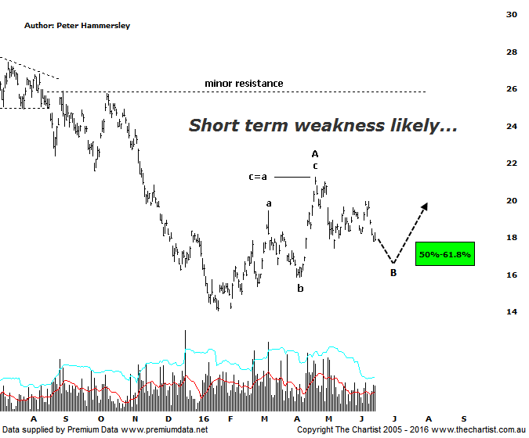

Bottom Line
16/6:
Daily Trend: Down
Weekly Trend: Down
Monthly Trend: Down
Support levels: $16.80 - $16.15 / $14.06 / $10.00 - $9.00
Resistance levels: $21.25 / $27.00 - $31.06 / $36.05
Video Analysis
Watch Video Analysis Here
Technical Discussion
BHP Billiton is a diversified natural resources company and operates through customer sector groups (CSGs). The Company operates in nine sections; Petroleum, Aluminium, Base Metals, Diamonds and Specialty Products, Stainless Steel Materials, Iron Ore, Manganese, Metallurgical Coal and Energy Coal. In May 2014, Cassini Resources acquired BHP Billiton Limited's West Musgrave Project. For the six months ending the 31st of December 2015 revenues decreased 37% to $15.71B. Net loss before extraordinary items was $5.67B against income of $3.86B. Revenues echo the Petroleum section decrease of 45% to $3.8B and the Iron Ore division decrease of 36% to $5.35B. Broker/Analyst consensus is currently “Hold”.
Reasons to be cautious:
→ The recent lawsuit is concerning.
→ Spot gas prices have been at their lowest level since 2001.
→ The dividend has been cut substantially.
→ Recent results have underwhelmed analysts and brokers.
→ Potential reversal zone now penetrated.
→ Aligned to the price of oil.

The risk was to the downside following our last look at BHP with the typical retracement zone sitting just beneath $18.00 likely being the next port of call. As can be seen price is hovering around the target zone now with one final movement down, likely to the lower boundary of the reversal zone required to complete a corrective pattern lower. This would complete Wave-B and set the stage for another rally. At this stage we are only looking for a countertrend movement higher as opposed to something more bullish medium to longer term although first of all let’s see if the lower target area is tagged and rejected. The wave equality projection aligns with the 61.8% retracement level which sits at $16.15 and is the reason for expecting a slightly deeper retracement. The only problem of course in regard to our expected trajectory is the state of the broader market as it’s extremely difficult to envisage the likes of BHP & RIO bucking the trend the XJO should the index continue to head south which is certainly feasible. As such, plenty of caution is required here although we can only concentrate on the patterns put in front of us with outside influences having to remain on the back burner. It would take a push above the recent pivot high at $21.25 to start thinking in terms of an interim low being locked in though from a pure pattern perspective we’d like to see those slightly lower levels tagged before that aforementioned level comes under pressure.
Trading Strategy
Over the past few months we haven’t wanted to be involved in any of the big four banks although the large miners fit into the same category - that is there’s been no reason to expect a significant rally. This remains the case with our focus of attention remaining on the smaller cap stocks as well as those in different sectors. However, if you are a fan of BHP then watch the target zone closely as strong demand returning within that area would be reason to dip your toe in. Should a larger A-B-C pattern higher unfold there is the potential for price to head up toward $24.00 and even possibly up toward the minor line of resistance a couple of dollars higher. Anything more substantial to the upside is looking highly unlikely looking at these patterns.

