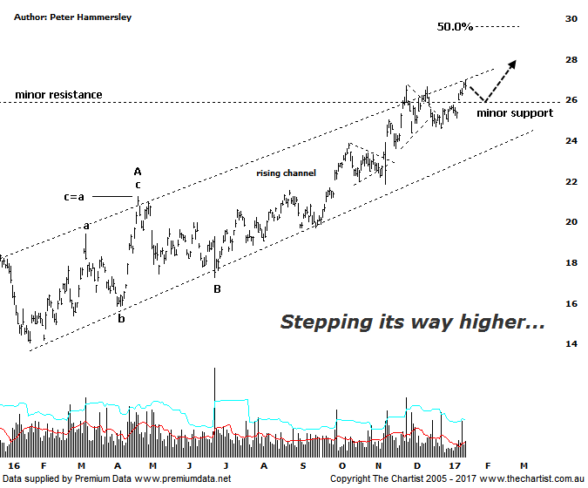
Bottom Line
17/1:
Daily Trend: Up
Weekly Trend: Up
Monthly Trend: Up
Support levels: $23.87 - $23.60 / $21.85 - $20.86
Resistance levels: $30.69 - $31.69
Video Analysis
Watch Video Analysis Here
Technical Discussion
BHP Billiton is a diversified natural resources company and operates through customer sector groups (CSGs). The Company operates in nine sections; Petroleum, Aluminium, Base Metals, Diamonds and Specialty Products, Stainless Steel Materials, Iron Ore, Manganese, Metallurgical Coal and Energy Coal. In May 2014, Cassini Resources acquired BHP Billiton Limited's West Musgrave Project. For the year ending the 30th of June 2016 revenues decreased 31% to $30.91B. Net loss before extraordinary items was $6.39B against. income of $3.42B. Revenues echo the Petroleum section decrease of 40% to $6.89B and the North America section decrease of 44% to $4.47B. Broker/Analyst consensus is currently “Hold”. The dividend yield is 1.5%.
Reasons to be cautiously optimistic:
→ A reported significant increase in the March quarter hard coking coal contract.
→ Won the rights to develop the Trion deep water oil project in the Gulf of Mexico.
→ Growth options remain.
→ 2017 should see reduced debt with the potential for shareholder returns.
→ The surge in coal prices adds plenty of weight to the earnings outlook.
→ Rising commodity prices provides upside risk.
→ Exposure to oil could be beneficial when compared to its peers.
The wave equality projection had been exceeded by a reasonable margin during our last review which opened the door for something more bullish to unfold. We were also focusing on a small pennant which was forming on a minor line of resistance circa $26.00. The upper boundary of a large rising channel had also been tagged. In other words, there was plenty going on in the chart which continues to be the case today. Price is still posturing around the upper boundary of the rising channel although it’s now managed to climb its way above resistance which should now be acting as support. It is feasible to come back down to support over the coming days although ultimately the door remains open for the trend to continue higher. BHP does tend to step its way higher as opposed to making strong clean trends although this is just a trait of the stock that’s unlikely to change any time soon. It isn’t reason for concern but it does mean patience is likely going to be required as price meanders higher. Looking at the weekly chart (not shown) reiterates the potential to head up to the typical retracement zone of the whole prior leg down off major highs. That target zone sits between $29.59 - $33.26 which is still a decent percentage gain, especially if the upper boundary is the next port of call which is more than feasible. Rising commodity prices are undoubtedly helping sentiment which hopefully will be a characteristic that continues as it would provide a big helping hand.
Trading Strategy
“…The small pennant does provide an opportunity if you want to be involved. The strategy is to buy following a break through the upper boundary of the small pennant with our bullish trigger being a probe above yesterday’s high at $26.07. The initial stop should be placed just beneath the prior pivot low at $23.59…” We are holding long positions and although no major headway has been made we have been able to tighten the trailing stop up to $24.40 where we’ll leave it for the time being. We must allow the trade room to breathe or we run the risk of getting stopped out during normal market noise. If you aren’t already involved it’s best to stand aside until another low risk entry presents itself.

